Array Modifier
You are given an array with integers. Write a program to modify the array elements after processing a sequence of commands “swap”, “multiply” or “decrease”. The commands are as follows:
“swap {index1} {index2}” takes two elements and swaps them.
“multiply {index1} {index2}” takes element at the 1st index and multiplies it with the element at 2nd index. Save the product at the 1st index.
“decrease” decreases all elements in the array with 1.
Input
On the first input line you will be given the initial array values separated by a single space.
On the next lines you will receive commands until you receive the command “end”. The commands are as follow:
“swap {index1} {index2}”
“multiply {index1} {index2}”
“decrease”
Output
The output should be printed on the console and consist element of the modified array – separated by “, “ (comma and single space).
Constraints
Commands will be: “swap”, “multiply”, “decrease” and “end”.
Elements of the array will be integer numbers in the range [-231...231].
Count of the array elements will be in the range [2...100].
Indexes will be always in the range of the array.
Examples
Input | Output | Comments
23 -2 321 87 42 90 -123  swap 1 3  swap 3 6  swap 1 0  multiply 1 2  multiply 2 1  decrease  end | 86, 7382, 2369942, -124, 41, 89, -3 | 23 -2 321 87 42 90 -123 – initial values  swap 1(-2) and 3(87) ▼  23 87 321 -2 42 90 -123  swap 3(-2) and 6(-123) ▼  23 87 321 -123 42 90 -2  swap 1(87) and 0(23) ▼  87 23 321 -123 42 90 -2  multiply 1(23) 2(321) = 7383 ▼  87 7383 321 -123 42 290 -2  multiply 2(321) 1(7383) = 2369943 ▼  87 7383 2369943 -123 42 90 -2  decrease – all - 1 ▼  86 7383 2369942 -124 41 89 -3

Solution
Read Input
We receive the integer numbers in a single line separated by space. So we need to split that line by space and to parse every number. Since we are going to multiply integers we can easily overflow it so we will use long data type.
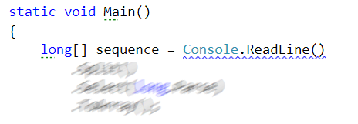
Command Execution Loop
Now we need to read and execute the commands on the next lines until we receive “end” as command
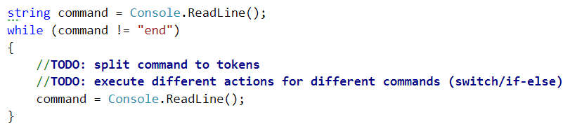
Hint
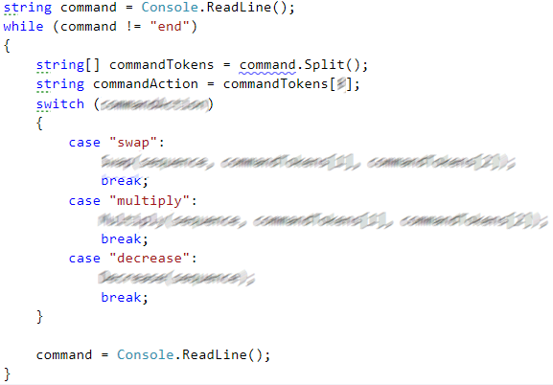

Helper Methods
We could define 3 methods to make the code more readable. And every method executes the appropriate command from the input. The methods receive as parameters the sequence and the parameters from the received command
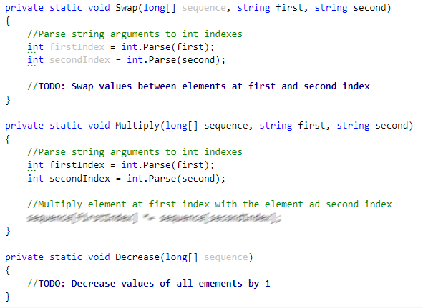
Print Result
Finally we need to print the final state of the sequence separated by a comma and space.

